CLASS: SY-B ENTC
PRN: 25UET075
NAME: SANIKA KESHAV ARDEKAR .
SLA-4:
Problem Statement 4: Multi-Agent System for Real-Time Decision-Making
INTRODUCTION:
The Multi-Agent System for Real-Time Decision-Making is designed to make quick and effective decisions in dynamic game environments. Real-time games require continuous analysis of changing game states, opponent actions, and available resources. Conventional approaches may experience delays or fail to adapt effectively to these changes.
This system uses multiple intelligent agents to analyze game information, evaluate possible actions, and make timely strategic decisions. The agents coordinate with each other, select suitable actions, and continuously update their decisions based on the latest game state. The C4 architecture represents the system at four levels: System Context, Container, Component, and Code, making its structure and interactions easier to understand.

C4 LEVEL 1:
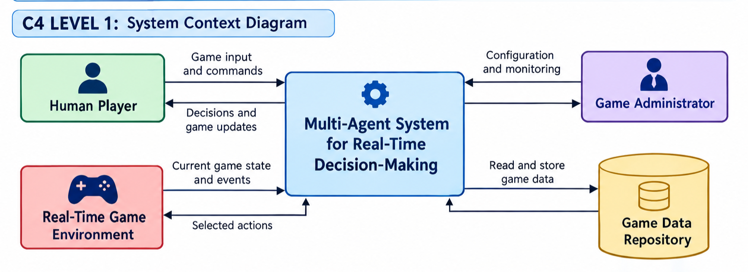

This diagram shows the overall system and its interactions with external entities, such as the human player, game administrator, game environment, and game database.

C4 LEVEL 2:
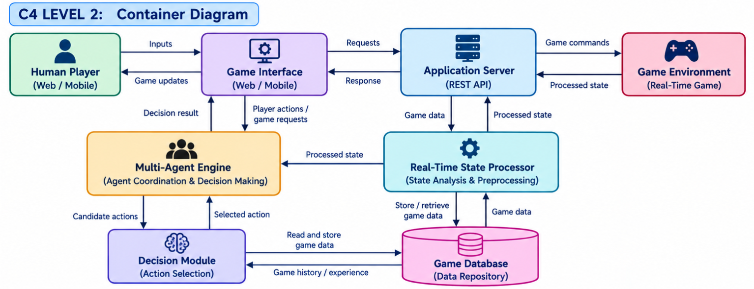

This diagram describes the major containers of the system, including the game interface, application server, real-time state processor, multi-agent engine, decision module, and database.

C4 LEVEL 3: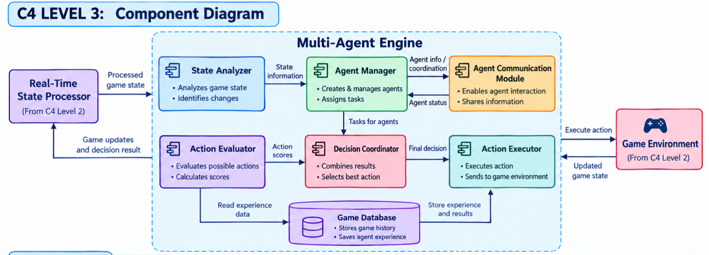

This diagram explains the responsibilities of the internal components of the Multi-Agent Engine.
Agent Manager: Creates, manages, and assigns tasks to intelligent agents.
State Analyzer: Analyzes the current game state and identifies important changes.
Agent Communication Module: Enables agents to exchange information and coordinate their activities.
Action Evaluator: Evaluates possible actions based on the current game state.
Decision Coordinator: Combines the agents' results and selects the most suitable action.
Action Executor: Sends the selected action to the game environment for execution.
The components work together to analyze game conditions, coordinate agent activities, evaluate actions, and execute decisions with minimum delay.

C4 LEVEL 4:

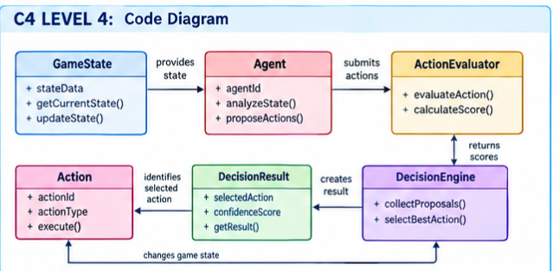
This diagram presents the internal modules of the Learning Module, including PolicyNetwork, ExperienceBuffer, RewardCalculator, and PolicyUpdater. These modules process game experiences, calculate rewards, and update agent policies to improve decision-making during future gameplay.

